Feb 2018

1. **Are the places with the most # larval mosquitoes consistent across years?** 
   * Avg number of early instar mosquitoes (1st sampling date at ponds)

**Maybe. But 2012 lowest abundance in all cases.**

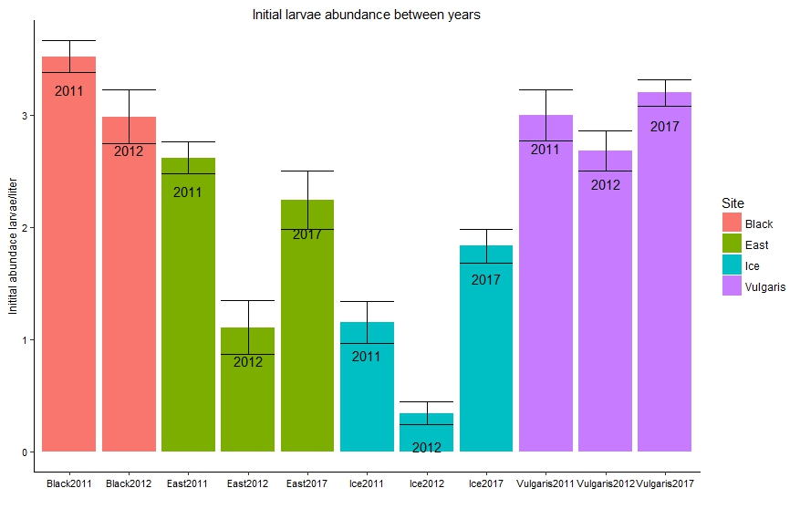

1. **Are the places with the most # of emerging mosquitoes consistent across years?**
   * Cumulative # from emergence traps

**No. But limited data to answer this question.**

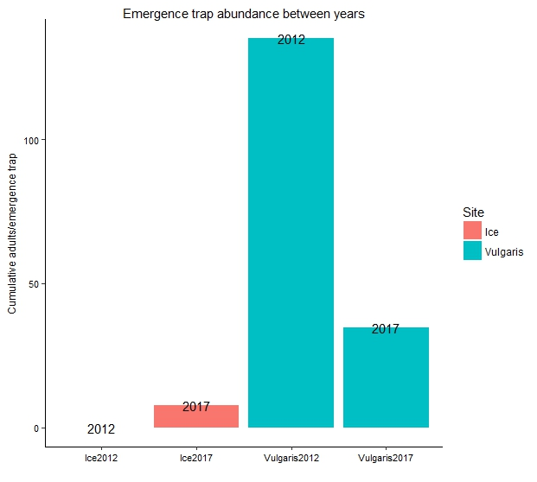

1. **Are the places with the most # of pupae consistent across years?**

**No. Variation between years and between ponds.**

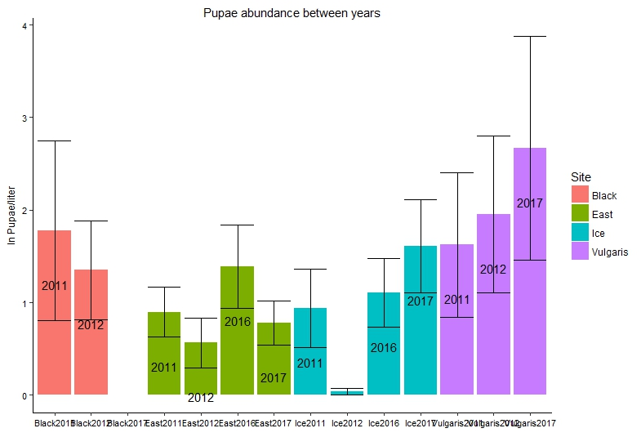

1. **Do ponds with more early instar mosquitoes have more pupae?**

**Yes. More early instars = more pupae = more emerging adults**

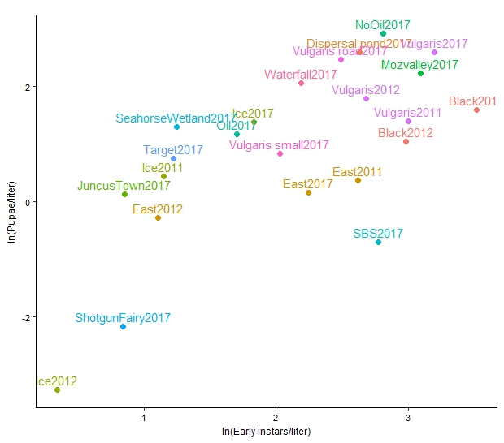

1. **Do ponds with more early instar mosquitoes have more emerging mosquitoes?**
   * Densities @ first sampling vs. cumulative # from emergence traps

**Maybe. Either no relationship, or positive**

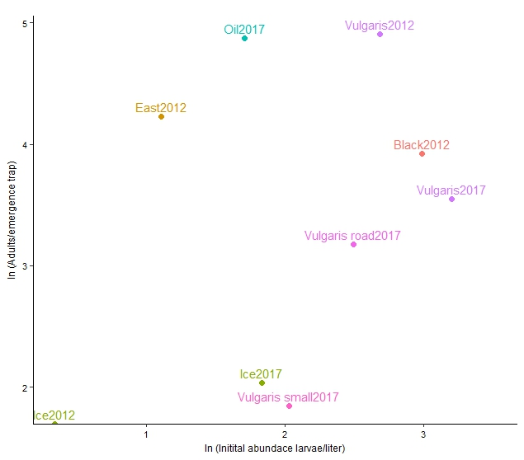

1. **Do ponds with greater densities of early instars have smaller emerging mosquitoes?**

**No it’s the opposite…when there’s more larval mosquitoes they are bigger**

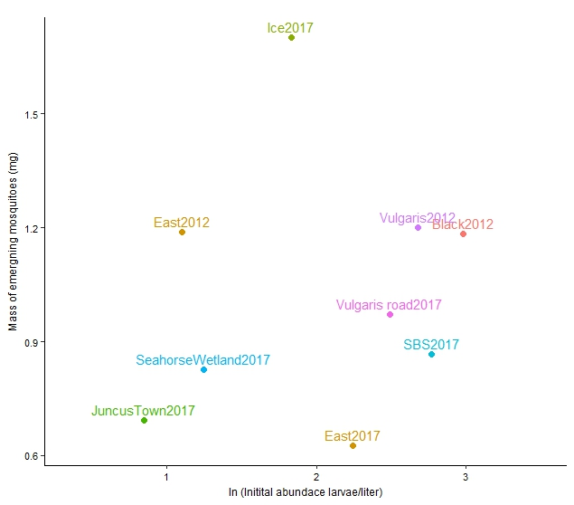

1. **Do ponds with more pupae have smaller emerging mosquitoes?**

**No.**

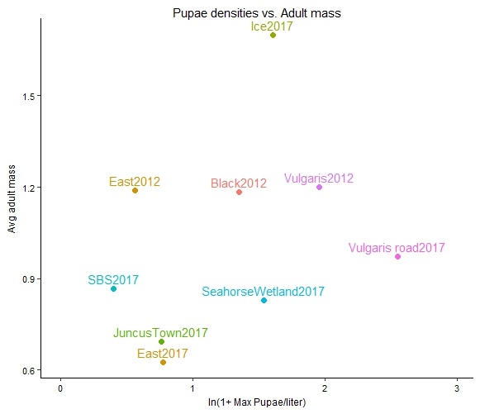

1. **Do ponds with more emerging mosquitoes have smaller emerging mosquitoes?**

**No obvious relationship, but not a lot of data**

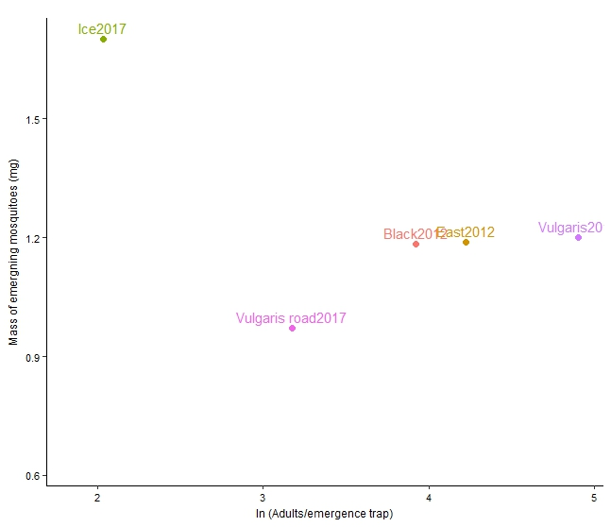

1. **Are the places with the most # beetles consistent across years?**
   * Used avg beetle densities across dates after beetles started showing up in ponds

**Maybe. But again, 2012 lowest abundance in all cases.**

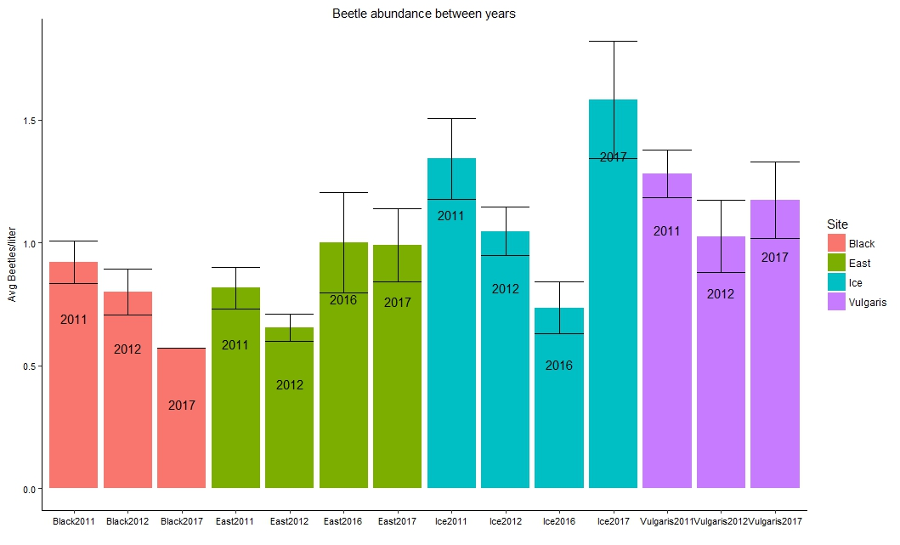

1. **Do ponds with higher densities of early instar mosquitoes have more beetle predators?**
   * Densities early instars @ first sampling (before there are beetles) vs. avg density of beetles

**Interesting! No relationship across ponds, but within ponds, in years with more mosquitoes there are more predators**

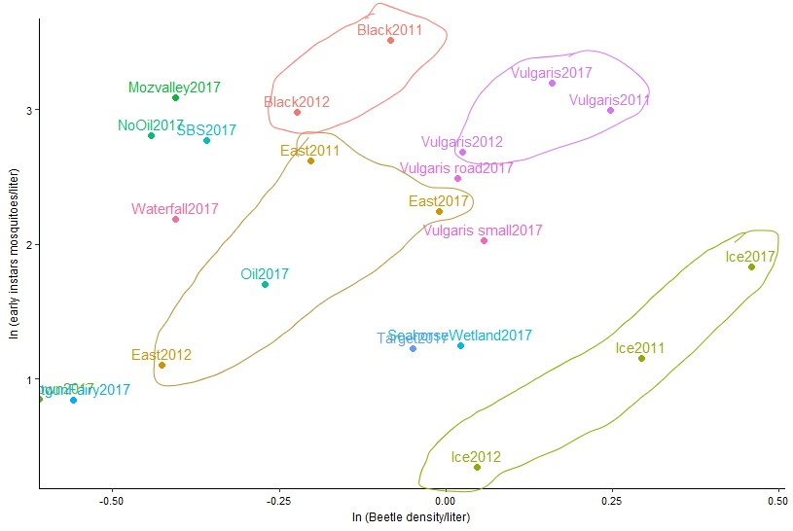

1. **Do ponds with greater densities of predators have fewer emerging mosquitoes?**
   * Avg predator densities vs. cumulative # from emergence traps

**No. Predator abundance in pond alone does not density of emerging mosquitoes**

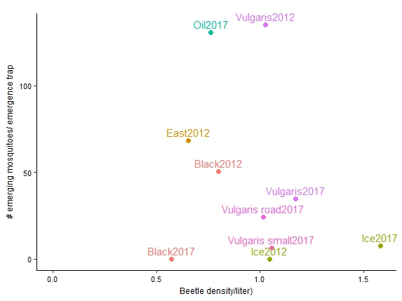

Densities

1. **Do ponds with more larval mosquitoes have smaller emerging mosquitoes?**
2. **Do ponds with higher per-capita mortality rates have fewer emerging mosquitoes?**
3. **Do ponds with higher per-capita mortality rates have smaller emerging mosquitoes?**
4. **How does per capita mortality change across years?**
5. **Do ponds with higher densities of larvae have higher per-capita mortality?**

Within the same ponds (looking across years) steeper slopes seem to be correlated with higher initial densities. BUT this doesn’t hold in comparing across ponds exactly. For example, Black and East have higher per capita mortality than Vulgaris even though initial densities are comparable.

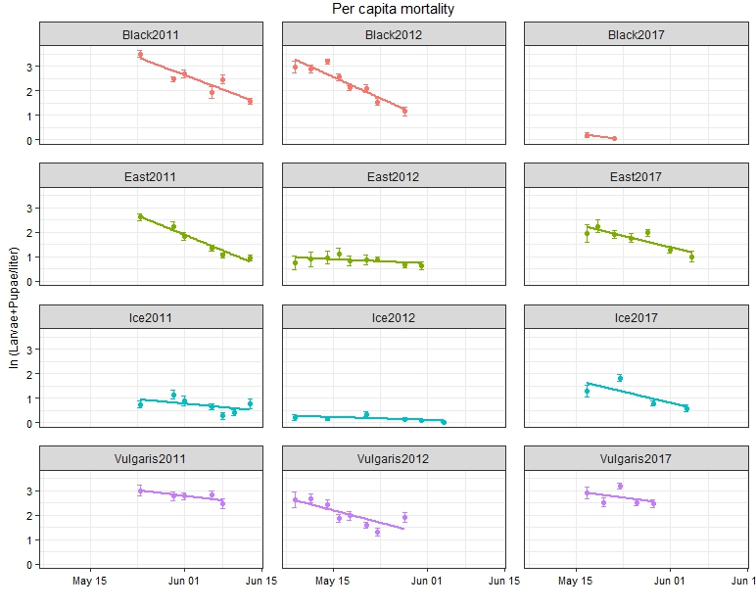

Temperature/Timing

1. **Do more mosquitoes emerge from warmer ponds?**

**Doesn’t seem like that. (but avg temp probably not the best metric)**

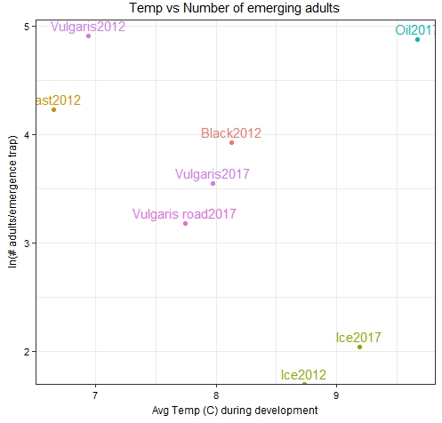

1. **Do mosquitoes emerge earlier in warmer ponds**

**Hard to tell from this because I plotted avg temperature in the ponds during larval development when I should probably use something like thermal sums.**

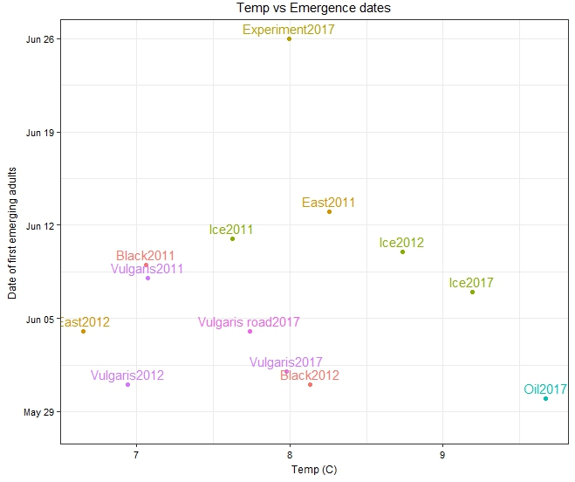

1. **Are mosquitoes that emerged earlier bigger?**
   * **No the opposite. Ones that emerged later are bigger**

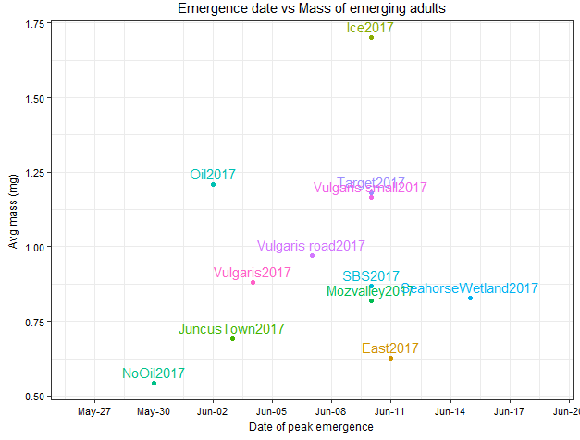

1. **Are mosquitoes that emerged in warmer temperatures?**
   * **Maybe? Not a lot of data, also avg temp is probably not the best metric**

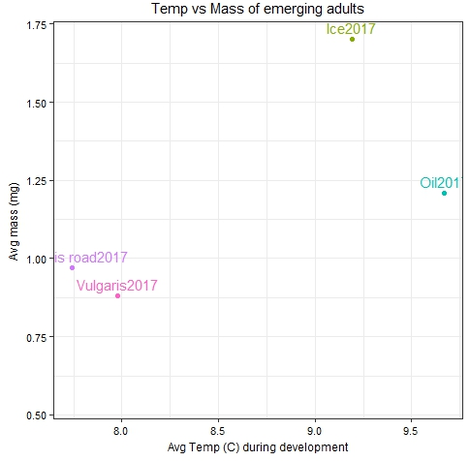

1. Do colder ponds have more days where mosquitoes and beetles overlap?
2. **What is the relationship between mass and wing length?**

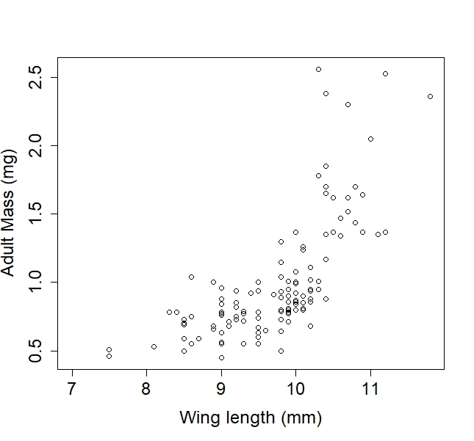

1. **Do ponds with a higher average mass of emerging mosquitoes have a greater variance in size distribution?**

**Yes, it looks like it. But some ponds have the occasional very large mosquito.**

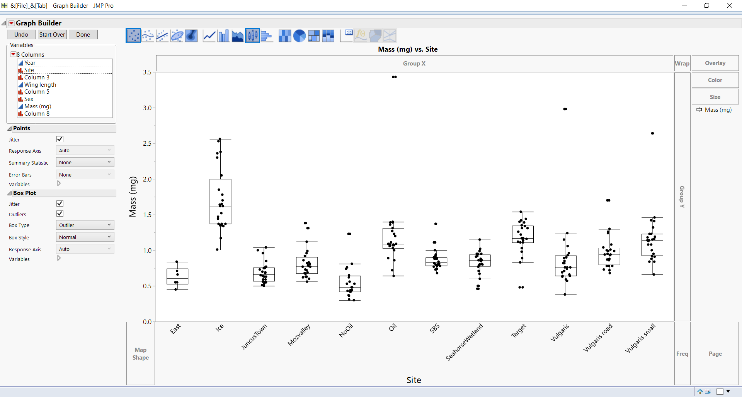

1. **Does size differ between male and female adults?**

**Not really. Females have slightly larger variance.**

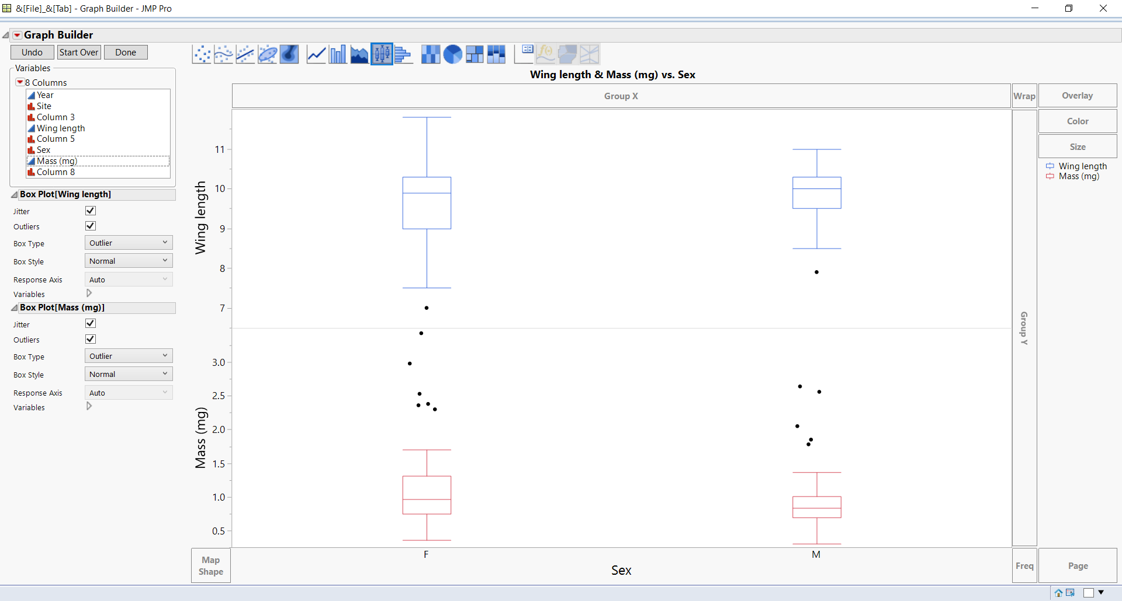

1. **Do sex ratios vary between ponds?**

**Yes. Average sex ratio is about 1.7F to 1 M.**

|  |  |  |  |  |
| --- | --- | --- | --- | --- |
| **SiteYear** | **Males/trap** | **Females/trap** | **Total/trap** | **F:M ratio** |
| 2012Black | 4 | 46.5 | 50.5 | 11.625 |
| 2012East | 43.5 | 25 | 68.5 | 0.574713 |
| 2012Vulgaris | 64.5 | 70.5 | 135 | 1.093023 |
| 2012Ice | 0 | 0 | 0 |  |
| 2017East | 1 | 1.333333333 | 2.333333 | 1.333333 |
| 2017Ice | 2 | 5.666666667 | 7.666667 | 2.833333 |
| 2017Oil | 28.33333333 | 102.3333333 | 130.6667 | 3.611765 |
| 2017Vulgaris | 18.33333333 | 16.33333333 | 34.66667 | 0.890909 |
| 2017Vulgaris road | 6.333333333 | 17.66666667 | 24 | 2.789474 |
| 2017Vulgaris small | 2.333333333 | 4 | 6.333333 | 1.714286 |
| **All** | **170.3333333** | **289.3333333** | **459.6667** | **1.69863** |

1. Are there more larval mosquitoes in places that are wet every year or places where it is only wet every couple of years (egg bank?)

Predators

1. **Do beetles appear earlier in warmer ponds?**
2. Is there a difference per-capita mortality before and after predators appear?

DOC (…ideally do this with better food data)

1. **Do ponds with more DOC have more emerging mosquitoes?**

**Yes/maybe? Here I have made an assumption that DOC measure in 2017 was the same as DOC in 2012 for the same ponds…**

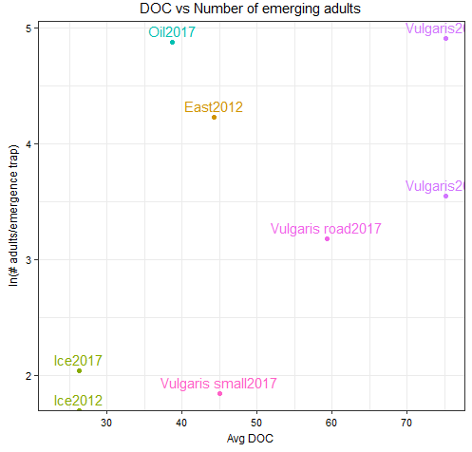

1. **Do ponds with more DOC have larger emerging mosquitoes?**

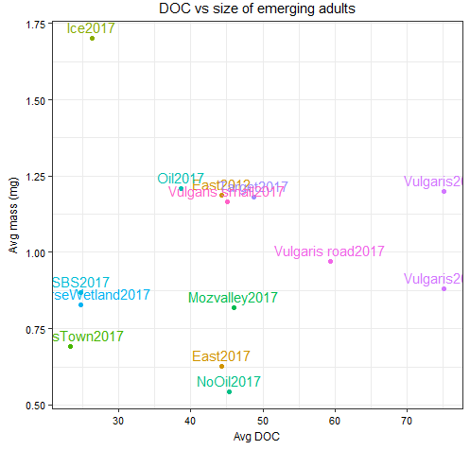

1. **Assuming constant DOC over the larval period, is there a relationship between per-capita mortality and DOC/density?**

Relative growth rate data

1. How does size distribution change as density decreases?
2. Do mosquitoes grow more slowly in colder ponds?
3. Do mosquitoes grow more slowly when there are more of them (food limited)?
4. Do mosquitoes grow faster in places with higher DOC? (or food…)
5. Do mosquitoes grow faster in places with higher DOC/density ratio?

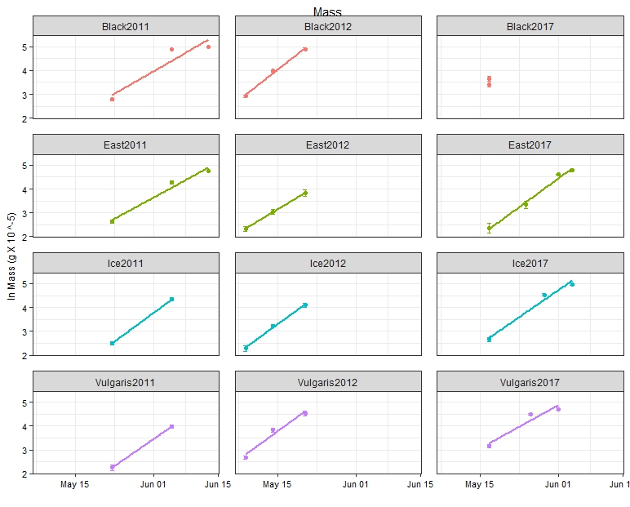

C02 trap data

1. Is adult mosquito abundance aggregated on the landscape?
2. Is mosquito abundance aggregated in the beginning (according to where they emerge) and then become more random/uniform over time?
3. Are there more mosquitoes in places where the probability of getting a blood meal is higher later in the season?
4. Will mosquitoes seek a blood meal on windy days?
5. Will mosquitoes seek a blood meal on cold days?
6. Will mosquitoes seek a blood meal on dry days?

Egg/sweep net data

1. Is the probability of getting a blood meal uniform across the landscape?
2. Are there more mosquitoes in places where the probability of getting a blood meal is higher?
3. Do bigger mosquitoes have more eggs?
4. What percentage of the population could be reproducing without a blood meal (autogeny)?
5. Where are the majority of blood meals coming from?

Stuff I don’t really have data on yet…

1. What makes a good mosquito pond?
   * In terms of # initial densities
   * # of emerging mosquitoes
   * AND size of emerging mosquitoes
2. What other aquatic inverts are eating the same food as mosquitoes?
3. Are there other organisms better at eating food than the mosquitoes (lower R*) and if so, why are they not in the mosquito ponds? (Are they dispersal limited?)